ME-Eye Idol-Bell-shaped body

SYRIAN WHITE STONE SPECTACLE IDOL   
TELL BRAK, CIRCA 4TH MILLENNIUM B.C.

Dimensions- **3 3/8 inches high (8.3 cms).**  
With bell-shaped body surmounted by two circular perforated 'eyes'  
Provenance- **Ex. Early European Private Collection, now Atlantika**

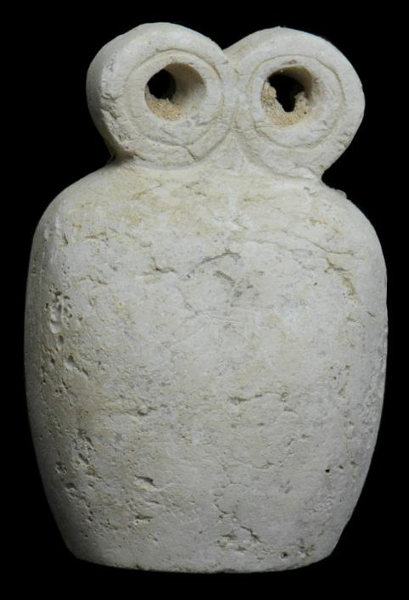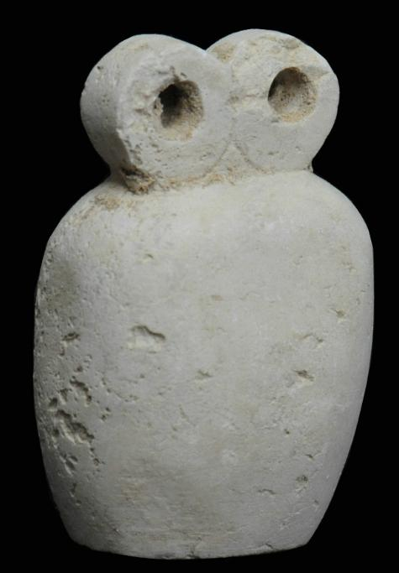

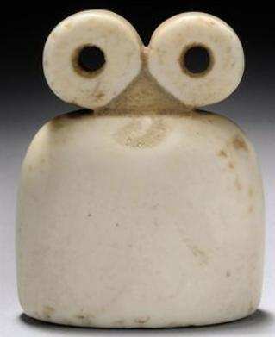

A SYRIAN WHITE STONE SPECTACLE IDOL   
TELL BRAK, CIRCA 4TH MILLENNIUM B.C.   
With bell-shaped body surmounted by two circular perforated 'eyes'   
2 1/8 in. (5.3 cm.) high

Provenance: Gawain McKinley collection, acquired prior to 1996, Christies'.

Price Realized: £8,125 ($12,927)